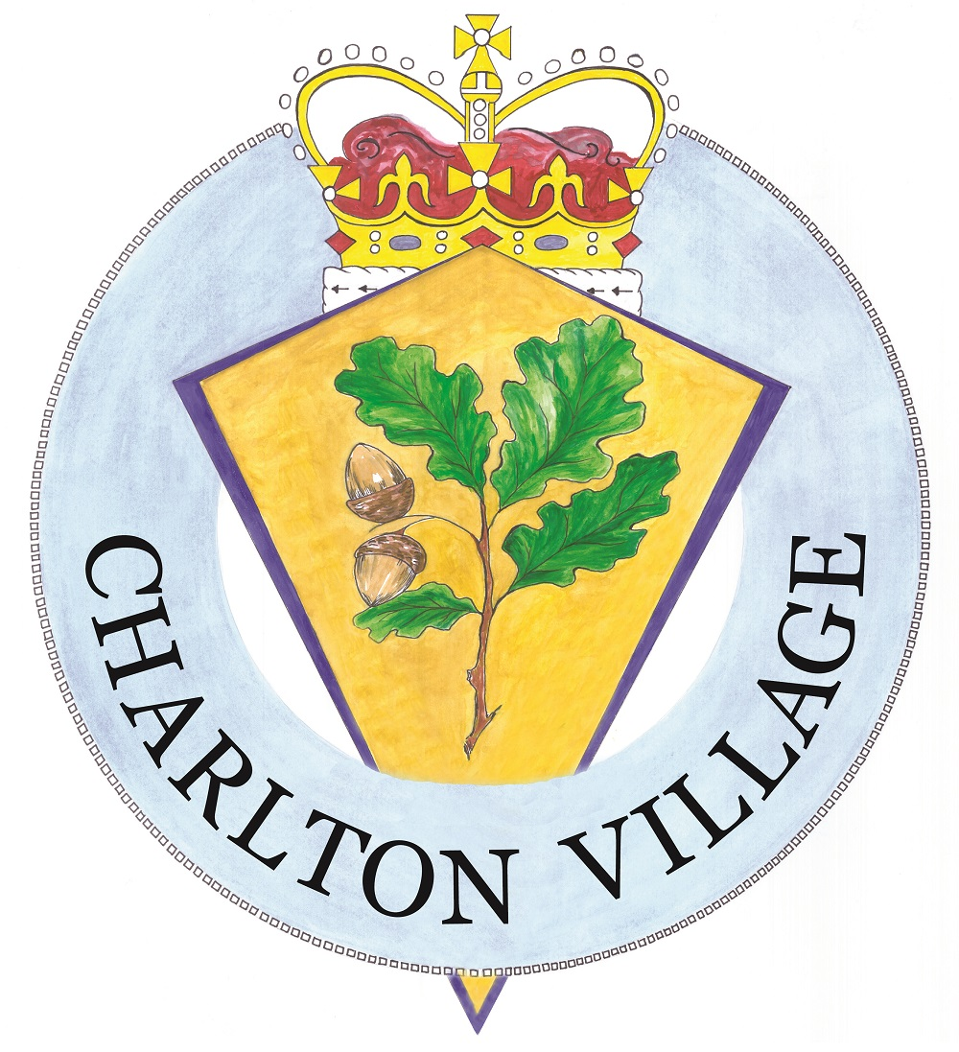

CHARLTON PARISH COUNCIL

Unacceptable behaviour and disorderly conduct

Introduction

Charlton Parish Council is committed to putting parishioners at the heart of service delivery. However, there are occasions when parishioners can act in a way we consider unacceptable. Charlton Parish Council expects its members and employees to be treated in a respectful manner, and whilst it is understood that people sometimes get frustrated, we will not tolerate behaviour which is deemed unacceptable, threatening, abusive or unreasonably persistent.

This document clarifies the process for handling unacceptable behaviour towards members and employees and benefits parishioners by increasing its transparency through a structured formal policy.

Definition

Charlton Parish Council defines unacceptable behaviour as behaviour which shows characteristics of discrimination, harassment, bullying, unreasonableness or vexatious or a combination of these.

- Discrimination: a failure to afford equal respect to an individual based on disability, gender, race, religion, age, sexuality and marital status.
- Harassment: behaviour which is unwanted and offensive and affects the dignity of the individual or group of individuals. Harassment is also defined as actions by a parishioner which because of their frequency or nature, hinder the parish council’s interaction with the parishioner.
- Unreasonable behaviour: parishioners who continually request complex information without apparent or good reason (such as that which people demand Freedom of Information Act) may be regarded as acting in an unreasonable manner.
- Vexatious behaviour: acting in a manner to cause annoyance or irritation without the intention of resolving their query.
- Bullying: a type of harassment which consists of persistent actions, criticism or personal abuse in public or private which humiliate, intimidate, frighten or demean the individual.

During a Meeting

Charlton Parish Council have every right to remove individuals causing a disturbance from a meeting.

- If the Parish Council anticipate the risk of a disturbance at a forthcoming meeting, which the Chairman of the meeting, or the meeting itself is unable to manage, the Clerk will contact the Police beforehand and request their assistance at the meeting.
- No person shall obstruct the transaction of business at a meeting or behave offensively or improperly. The Chairman will request any such person(s) to moderate or improve their conduct.
- If person(s) disregard the request of the Chairman of the meeting to moderate or improve their conduct, any Councillor or the Chairman of the meeting may move the motion that person(s) be no longer heard or excluded from the meeting. The motion, if seconded, shall be put to vote without discussion.
- If person(s) refuses to leave a meeting after there has been a resolution to this effect, and the meeting cannot proceed due to person(s) continued disruptive behaviour, the Chairman may suspend or ultimately close the meeting.

Outside of a Meeting

If any member or employee of the Parish Council feels that person(s) is behaving in a manner which they feel is unacceptable they can:

- Politely explain that the Parish Council expects its members and employees to be treated with respect and ask the person to moderate their behaviour.
- If the behaviour continues, members and employees will give a warning of further action appropriate to the method of contact e.g. warning that the telephone call will be terminated or being asked to leave the premise.
- If the person does not moderate their behaviour after this warning, the threatened action should be taken.
- The circumstances of the incident should be noted as should the time and date, on which it occurred and the full council should be informed.

If the person persists in their unacceptable behaviour, it may be necessary to consider additional measures. Any incident should be reported to the full council and sanctions decided upon. These sanctions may include:
- Restricting contact to a form (e.g. telephone).
- Limiting permissible contact to certain times and days;
- Specifying a member or employee to be the sole point of contact with the person in question.
- Asking the person to enter an agreement about their future conduct.

If the person(s) behaviour is judged to be violent or aggressive towards a member or employee, then the member or employee should:

- Terminate the interaction with the person
- If the behaviour is perceived to be so threatening, that the safety of the member or employee is at risk, the Police should be contacted.
- The circumstances of the incident should be noted as should the time and date, on which it occurred and the full council should be informed.

The full council may decide to:

- Explore whether legal action should be taken.
- Require the person to provide a written declaration that they will not act in such a manner again in the future.

Record of Adoption, Review and Amendment made to the
Charlton Parish Council’s ‘Unacceptable behaviour and disorderly conduct’

Date | Details of adoption, review or amendment
20/02/2018 | Adopted at Full Council under item 12.3
May 2019 | Review date.
March 2024 | Reviewed March 2024
 | Next review 2027

