Dear Councillor,
You are summoned to attend the following meeting of Charlton Parish Council.
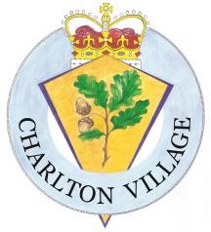
Signed Eveline Attwood Parish Clerk email to clerk@charlton-pc.gov.uk
Eveline Attwood 14/04/2026

Meeting of Charlton Parish Council
Monday 20th April 2026 at 8.30pm at Foxcotte Room
St Thomas Church Charlton
AGENDA

1 |  | Apologies of absence to be reported and approved.
2 |  | Cllrs to declare any interests in the items listed within this agenda
3 |  | Cllrs to approve the minutes from the Parish Meeting 16th March 2026
4 |  | Public Participation: This item is limited to 15 minutes and only allows questions and comments in relation to business as itemised within this agenda..
5 |  | Clerks Report – a report on matters being actioned by The Clerk
6 |  | Reports from County Councillor Donnelly
7 |  | 7.1 Finance & Policy - Cllrs to approve the financial statement to 31st March 2026  7.2 Approval of the end of year accounts 25/26  7.3 Cllrs to approve payments to be made March & April 26 to date.  7.4 Approval of accessibility statement  7.5 Approval of Scheme of Publication
8 |  | Planning - To consider any planning applications received since the last meeting
9 |  | Close of Meeting – The next meeting will be the Annual Council meeting and will be held on Monday 11th May 2026 at 7.00pm in the Church Hall.

+

