
HAMPSHIRE COUNTY COUNCIL UPDATES
July 2025
Andover West

Please find below an outline of current programmes of work and public information from Hampshire County Council. I hope that this is useful.

If you have any further questions, then please don’t hesitate to contact me at cllrc.donnelly@hants.gov.uk

Kind regards

Chris

___________________________________________________________________________

Local Government Reform

Last week, Hampshire County Council approved its proposals for the new unitary authorities for Hampshire. Their view is that there should be three mainland unitaries plus the Isle of Wight. The logic behind this is that it is the most administratively convenient and supposedly cheapest way of ensuring that social care and childrens’ services can continue.

I voted against these proposals. You can see my speech in the council here at 3:07:30: https://www.youtube.com/watch?v=OgtMS1o-dz0

I also wrote a column for the Advertiser which you can read here: https://www.andoveradvertiser.co.uk/news/25322073.column-test-valley-shouldnt-merge-southampton-new-forest/

I did so on the following grounds:

- Eastleigh and Southampton have a combined debt of £1 billion. With no Government guarantees of ringfencing these debts, we would be exposed to servicing these payments and immediately be in debt on day one.

- Southampton and Eastleigh are already either totally or almost completely developed. New Forest is largely protected as National Park. This means that when the new council comes to make a Local Plan, the housing will need to be concentrated in Test Valley, putting further pressure on our infrastructure and ecology.

- Southampton is a heavily urban area compared to our rural villages and market towns, and no council in England has such a diverse population to serve. Incidentally, it would be the second largest council in Europe after Birmingham, which is hugely in debt and cannot collect the bins. Bigger does not mean better or more sustainable.

The County argue that each district needs to be allocated to a council which already provides social care. I don’t accept this – these departments can be placed in any new council. They will also find that social care in Southampton is very different to social care in rural areas.

This was not done with the endorsement of Southampton, Eastleigh or New Forest, who all agree that this is not the right solution. It was suggested by HCC over their heads.

Voting against the proposals was not an easy decision, and I have come in for some criticism from county colleagues for doing so. However I am elected to represent you and from our extensive conversations over the past few months, I do not believe that the majority support becoming part of Southampton. I therefore had to stand up for our residents.

The County has now begun a consultation on what you think about their plans. The following link will give you an explanation of the rationale from their point of view.

Please take five minutes to fill it in and let them know your view. Please could I also ask parishes to circulate this as much as possible please to get a high turnout from this division.

https://www.hants.gov.uk/aboutthecouncil/governmentinhampshire/future-hampshire-solent/local-government-reorganisation

Local Plan

Test Valley Borough Council are now consulting on the new Local Plan. I approach this from the county perspective of infrastructure provision.

As a reminder of why we are here, we already had a Local Plan in force, but the Government decided to increase our housing numbers by 78% overnight. Despite asking Angela Rayner for a transition period, they did not provide one. This meant that overnight our Local Plan became obsolete, as we didn’t have the required land supply to deliver the new number of houses.

As a result, there is a presumed right to develop on all land in the borough without infrastructure being provided. Test Valley have very little leeway to turn it down and recently houses had to be approved in Goodworth Clatford against the wishes of the committee.

We have therefore been forced to write up a new Local Plan to try to provide protection for our communities against uncontrolled development. This has to identify land supply, which is proposed by landowners, and will also compel developers to provide infrastructure and meet design requirements.

My main concern is the impact along the A342 from Portway to Ludgershall, with thousands of houses potentially in the pipeline. Add to that Wiltshire County Council’s allocations in Ludgershall and we have a potentially severe strain on infrastructure, especially around Weyhill.

I am delighted that my colleague, Cllr Phil Lashbrook, who represents Bellinger ward, has agreed to chair a pan-parish forum to co-ordinate the responses of parishes along this corridor and set out clear parameters for any infrastructure required. His experience and knowledge will be invaluable in navigating this complex area.

The Borough are currently having exhibitions about the Plan. The meeting in Weyhill was very well attended and there will be more across the borough in the coming weeks.

You can find out more about the Plan at this link: https://www.testvalley.gov.uk/planning-services/planningpolicy/local-development-framework/draft-local-plan-2042

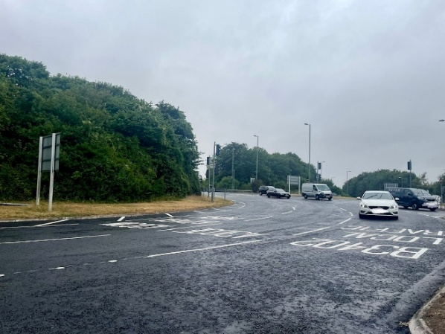
Hundred Acre Roundabout

Finally, some good news, the Hundred Acre Roundabout has been resurfaced and relined! This has been a long fight to get it included on our works list, but I’m really pleased that it has finally been done ahead of the winter.

Grateley Play Park

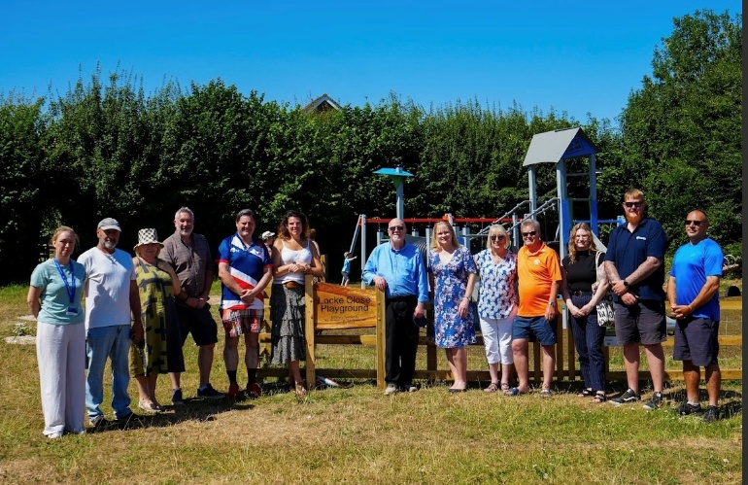
It was great to be able to join Grateley Parish Council and our MP, Caroline, for the official opening of their new play park. This is the culmination of years of effort to provide a first class play facility for the children of the village. The morning of the unveiling was extremely hot and unfortunately the slide was too hot to use, which probably saved a little of my dignity! I did, however, test the zip wire to the extremes of its load bearing weight and it performed magnificently.

Well done to everyone in Grateley for this fantastic achievement.

Charlton and Amport Community Days
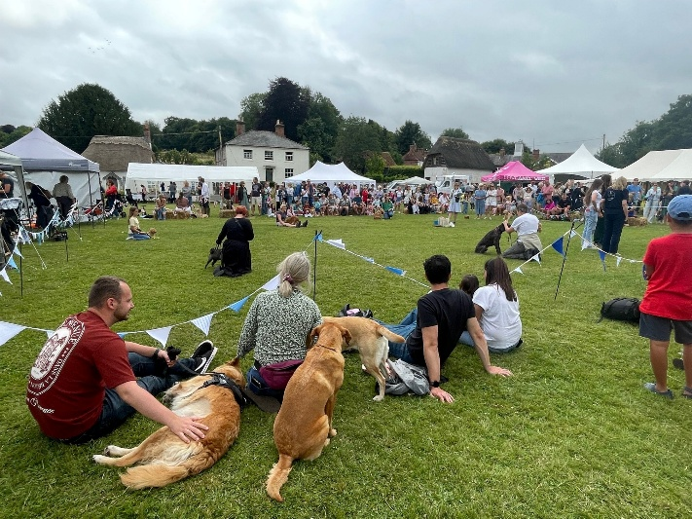
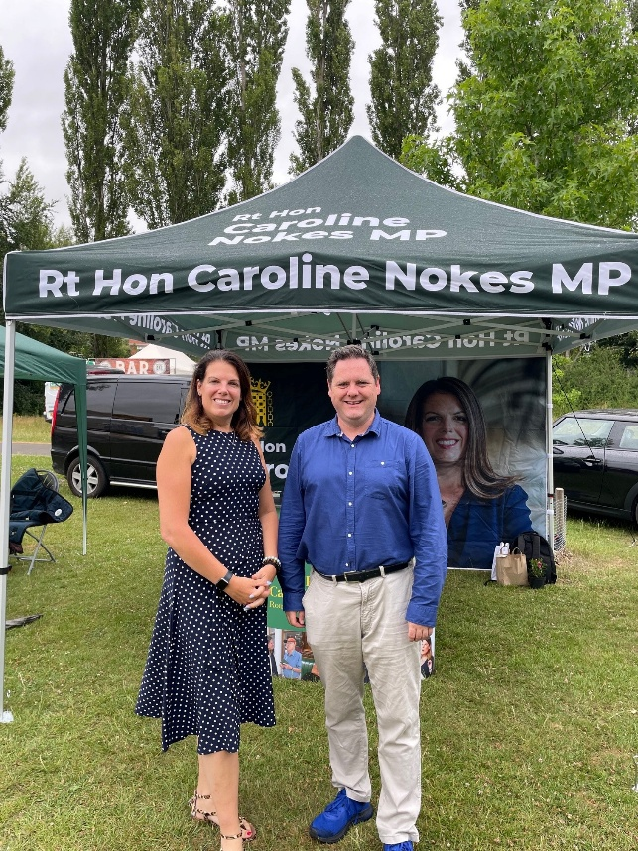
I had a great time at the Charlton and Amport Community Days this month. Despite the slightly wet weather, they were brilliantly organised and supported. Caroline and I spoke with residents in Charlton and in Amport I was fascinated to see how many little insects and plant life lived in our chalk streams. The parishes are doing a very thorough job in helping document and protect our chalk streams, and we have a motion coming to the upcoming Full Council at Hampshire urging the government to strengthen their protection.

Reporting Highway Problems

Links to report road issues are here:

Missing or damaged signs: https://www.hants.gov.uk/transport/roadmaintenance/roadproblems/brokensigns

Potholes: https://www.hants.gov.uk/transport/roadmaintenance/roadproblems/potholes

Tree/hedge problems: https://www.hants.gov.uk/transport/roadmaintenance/roadproblems/treehedge

Flooding/drainage issues: https://www.hants.gov.uk/transport/roadmaintenance/roadproblems/flooding

Pavement problems: https://www.hants.gov.uk/transport/roadmaintenance/roadproblems/paving

Problems with rights of way:

https://www.hants.gov.uk/landplanningandenvironment/rightsofway/reportaproblem

When reporting an issue, you’ll be sent an email confirming a reference number for the report. If you would like me to follow this up for you then do please forward that message to me and I will chase for you.

