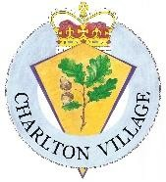

CHARLTON PARISH COUNCIL
MINUTES OF THE MEETING HELD ON
Monday 17th November 2025 at Charlton Church Foxcotte Room at 7.00pm

Present: Cllr Ward Chairman, Cllr Woods (Vice Chairman), Cllr Wilson, Cllr Mockford,
In attendance: E Attwood – Clerk
1 Member of the public

- Apologies for Absence – Cllr Tasker, Cllr Curry, Cllr Brown, Cllr Summers Borough Councillor Lashbrook

- Declarations of Interest
None

3. Minutes - Resolved: The minutes of the Parish Council meeting held on 20th October 2025 were confirmed as a correct record and signed by the Chairman of the meeting. All members agreed.

4.Public participation – None

5.Clerk’s Report
- Both fixed rate investments transferred into 95-day notice account, accruing daily interest.
- Tree survey for Charlton Waterside trees circulated to Cllrs and quotes have been obtained for recommended tree husbandry.
- Lengthsman grant has a small amount to be spent.
- Section 137 investigated and it can be used riverbank repairs as a last resort - Site meeting with Environment Agency requested - awaiting EA response.
- A structural Survey of the bridge at the end of Charlies Lake Lane can be paid using section 137 as a last resort, the PC has no powers to repair bridge.
- There are markings on the pavements outside Carters Meadow indicating the dropped kerb will be replaced. The Clerk will ask Highways if they are implementing the requested aligned kerbs.
- Resident phoned about CVCA and Church event being the same weekend, she said residents were finding it confusing.
- Section 137 calculation was shared with Cllrs £11.10 times 1682 electors = £18670 for next year, it had been requested that this allocation may be required for bridge survey and riverbank repairs.

6. County Cllr Donnelly – The following was reported: (full report on website)
- Parish Council bus shelter grant scheme
- Resurfacing of Foxcotte Road and other local roads
- Government Devolution consultation starts this week – details on the website.
- Details of County Councillor grants

7.Charlton Waterside – Cllrs discussed the tree Survey. It was agreed that T10 was not on Parish Council Land and should not have been included in the survey. The Clerk had obtained two quotes to carry out tree husbandry for T2 Sycamore & T6 Common Ash as recommended in the tree survey by the arboriculturist and had requested approval to carry out the work. The Clerk advised before the decision was made that by not carrying out the recommendations of the arboriculturist, the Parish Council has invalidated its insurance and that health and safety should not be compromised and that the Parish Council would be liable should an accident occur.

Resolved: Cllrs decided that the Clerk should obtain quotes to pollard both trees as that they were not convinced bracing was the best way forward and wanted time to consider other options. The quotes will be considered at the January meeting.

8.Lane accessing Charlies Lake and bridge exiting lane (name to identify location)
It had been reported that the bridge exiting the lane maybe unsafe for vehicles to use. It was reported that the bridge is not the Highways or TVBC’s or the Parish Council’s responsibility to maintain. It is on unregistered land and has no known owner. Resolved: The Clerk will obtain quotes for a structural survey of the bridge to determine if the bridge is safe for vehicles. One quote had been obtained but further quotes were required. HCC bridge dept have confirmed they are not able carry out the structural survey.
Eroding Riverbank
The Clerk had contacted the EA for a site meeting and is still waiting a reply. Resolved: Parish Cllrs agreed to remove debris from the area once the water levels drop and await the structural survey of the bridge before further discussions take place.

9.Finance -
9.1The bank balance as of 31st October 2025 was as follows:

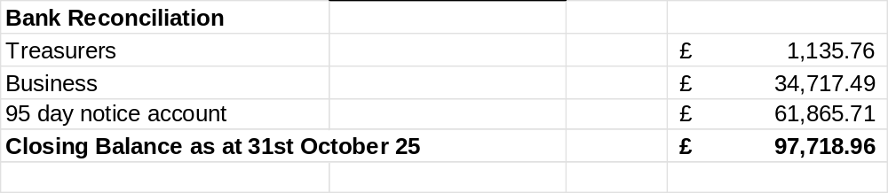
Resolved: Councillors approved the financial statement and payments for 31st October 2025.

9.2 Approval of October 2025 payments.
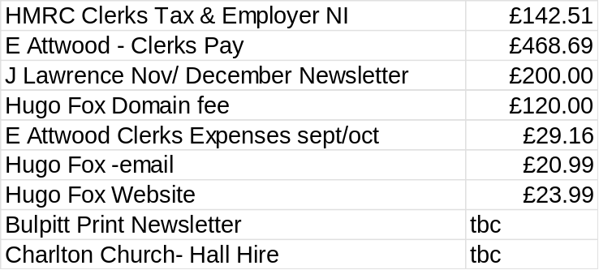

Approval of November & December payments to date.
£585.87 November salary
£585.87 December salary
Resolved: Cllrs approved October, November, and December payments to date.

9.3 Approval to reward litter pickers.
Cllrs discussed a small thank you to the volunteer litter pickers. Cllr Ward did not take part in discussions. Resolved: Cllrs approved a hot drink and slice of cake at the Royal Oak Charlton after the next litter pick as a token of appreciation.

9.4 Budget – The Clerk reminded the Council of the External Auditors advice on the AGAR published in September 2025. The Clerk produced a choice of three budgets. Resolved: Cllrs approved the budget. See Appendix A

9.5 Approval of the Precept – Resolved: Cllrs approved the precept to remain the same as the previous year which is £40,000 for the year 26/27.

9.6 Approval of Earmarked Reserves – Cllrs discussed and approved the following.
- Parish Reserves £30,000 allocated
- The Neighbourhood Plan will be due for updating and approval next year. £4000 allocated
- A lawnmower is required for keeping the countryside rights of way now that HCC no longer have the resources to maintain them. £1000 allocated
- Cllr Ward reported that he had discussed a possible alternative Community Hub since the last meeting and although details cannot be shared at this time. Cllrs approved £50,000 to be earmarked for this project which is looking probable.
- Resolved: Cllrs approved the following reserves for 26/27

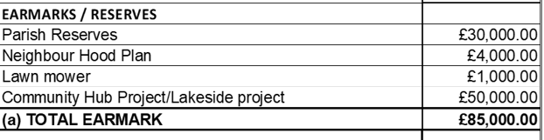

9.7 Approval of Internal Auditor – Resolved: Cllrs approved Tim Light as the internal auditor for 25/26 at a cost of £450.00.

9.8 Quarterly Statement Check – Cllr Wilson check the bank statements to the financial report and signed to confirm the bank balances were recorded correctly.

9.9 Laptop – Resolved: Cllrs approved the purchase of a chrome book to the value of £250 for the speed indicator data to be downloaded and collated by Cllrs. Cllrs will check if they have a spare personal laptop before proceeding with the purchase. Cllrs were reminded that the Clerk needs to make the purchase at Curry’s using the Parish Council debit card so VAT can be reclaimed. It is not possible to use personal Amazon accounts.

10.Planning - No new applications
11.Councillor Reports
11.1Traffic Liaison – Cllrs discussed recording and sharing of the data with the community and Police. The new laptop will enable Cllr Wilson to download the associated data.

11.2 Rights away & Lengthsman scheme- Resolved: 1st Home Improvement (Shane Cole) could be approached to clean the bus shelter and remind him the Goch Way signs were not cleaned. The restricted by way behind the Old Nursery Cottage is still walkable but will require cutting back in the spring.

11.3 Emergency Resilience Planning – Cllrs Wood & Cllr Ward had discussed the ERP and were planning an Ice WhatsApp group for emergencies. This item will be added to the action tracker. This will be removed from the agenda.
1.4 Charlton Waterside – This will be removed from the agenda as a resident regularly tidies this area.

12.5 Charlton Village Community Association – Cllr Ward reported that the Annual General meeting has taken place and next year’s events have been decided. The Christmas market and lights switch will be on the 30^{th of} November. (Church Christmas Fayre is on the 29^{th of} November.

12.6 Communication update with proposals – This will be removed from the agenda as it is the CVCA who are organising. They are hoping to retrieve the old Charlton Website domain.

12.7 Action Tracker – Cllr Ward will upload to google drive as it is not updateable in the members area.
- Correspondence & Meetings. The following items were received.
- A member of the public had phoned the Clerk to explain her confusion over the Christmas events.
14. Items for next months
- Restricted by way maintenance behind The Old Nursery.
- Approval of CVCA grant
- Co-option of Councillor
- Tree work at Charlton Waterside

- Date of next meeting: Please note new time & date. The next Council meeting will be held on Monday 17th November 2025 in the Foxcotte Room at St Thomas Church at 7pm.

Appendix A – The Budget 2026/2027
